Golf Greens

Pack Mules

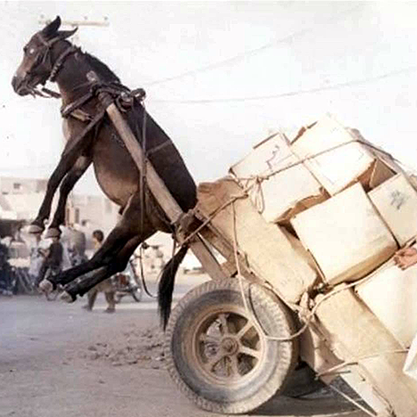

Domenic Pullar-Khan

Kenneth Mak

**Overview**

Golf Greens is a golfing game built using a 2D top-down physics based game engine. It is set using a mini-putt style arena, where the overall distance really is not too far and the main features are the obstacles in the way, including moving objects, gaps that require timing to pass, and more.

**Core Gameplay Mechanics**

* Choose to aim the ball in a direction by clicking on the ball, and dragging in the direction you want to shoot. The further you drag the stronger the power
* Collision between the ball and other objects. The other objects can be stationary (walls, barriers) or moving objects (rotating blocks, spinners, etc.)
* Try to hit the ball into the goal/hole with the lowest score

**Targeted platforms**

* Mobile Devices
* Handheld devices

**Monetization model**

Golf Greens will use **ads** as its monetization model, with an option to purchase a premium service to remove all ads permanently. Ads will play halfway through the course or at the end of the course. Small banners will also show up in the main menu and in the scoreboard.

**Project Scope**

This project will take approximately 3-4 months to get the main features working. The first two months will be handling the physics-based aspects, the collision calculations and the core features, and the remaining ones will be the map building and QA testing

**Team**

**Pack Mules**

* Domenic Pullar-Khan
  + Programmer/Coder
  + Assets Manager (Audio, Images)
* Kenneth Mak
  + Programmer/Coder
  + Documents Manager

**Influences**

* MiniPutt – Small ‘Golfing’ Game
  + An offshoot style of golf where the courses are much shorter in length, and focuses on obstacles and barriers for the player
* Golf It! – MiniPutt Golf Game
  + A recently launched Early-Access game of miniputt on the Steam store
* SovietWomble – YouTube Gaming Channel
  + A YouTuber that recently played through Golf It and showcased its popularity to over a million subscribers

**The Elevator Pitch**

Golf Greens is a classic mini-putt game with simple and fun courses that can be played in short periods of time, featuring solid and satisfying mechanics for the player.

**Project Description**

Golf Greens is a mini-putt style of game that features simple and fun maps for the player to experience. Golf Greens is designed for mobile and handheld devices and encourages short burst of play time in each map.

Obstacles and barriers encourages some forethought and timing in the maps in order to sink the ball quickly, and with each map accomplished, newer features will be encountered that enhances your gameplay.

**What sets this project apart?**

Golf Greens is a simple game to play while on the move, or if you are playing for a short time. While waiting for the bus, riding on transportation, and having that 5-10 minutes of a break in between classes, Golf Greens is meant to be an option for you to fill that time in.

Golf Greens should feature satisfying mechanics where the movement done should reflect exactly how the player intended it to be. Versatility of map designs and potential to implement newer features into the engine increases the longevity of the game and could allow the playerbase to create their own custom maps.

**Assets**

**2D Textures**

* Background Textures
* Obstacle Textures (Walls, moving parts)
* Golf ball texture

**Sound**

Sound List (Ambient)

* Background Music

Sound List (SFX)

* Strike the ball
* Collision with objects
* Sinking the ball into the hole

**Code**

* Actor Scripts (Collision boundaries, mass, anchored)
  + Position, Rotation, Scale
  + Walls, stationary objects
  + Velocity & Acceleration added to moving objects
* Ambient Scripts (Runs in the background)
  + Scoreboard, object movement
* Physics Scripts
  + Calculates trajectory, velocity, acceleration of all objects and also handles the collision between objects (This script is called)